PLUGGING INTO THE FUTURE: AN EXPLORATION OF ELECTRICITY CONSUMPTION PATTERNS

1.INTRODUCTION:

**1.1 Overview**

**India is the third largest producer of electricity in the world. During the fiscal year(FY) 2019-2020, the total electricity generation in the country was 1,598 KWh, of which 1,383.5 KWh generated by utilities. The gross electricity consumption per capita in FY2019 was 1,208 KWh.**

**1.2 Purpose**

**There are many reasons why organizations undertake these projects but the two main reasons include (1) to reduce electricity bills (2) and to reduce the environmental impact of their operations or facilities.**

2.PROBLEM DEFINITION & DESIGN THInking:

**2.1 Empathy Map**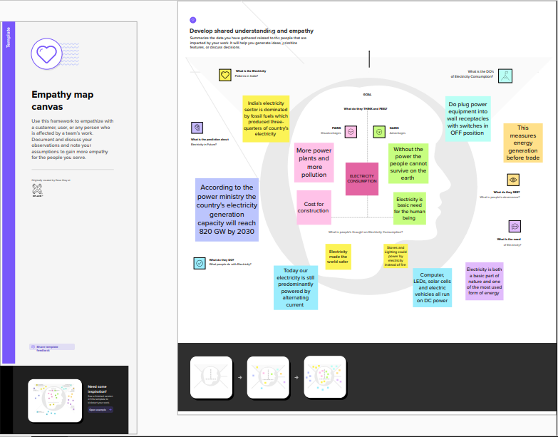

**2.2Ideation & Brainstorming Map**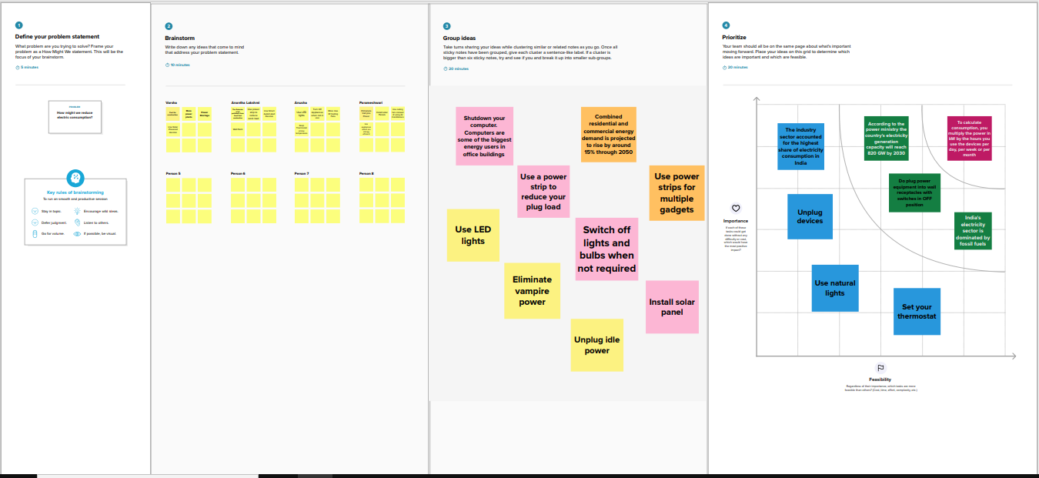

3.Result:

**Dashboard**

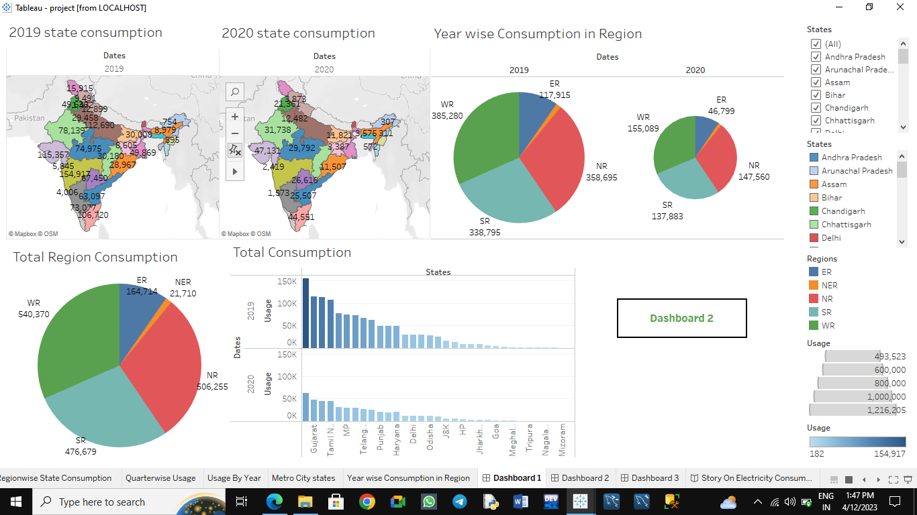

**Stories**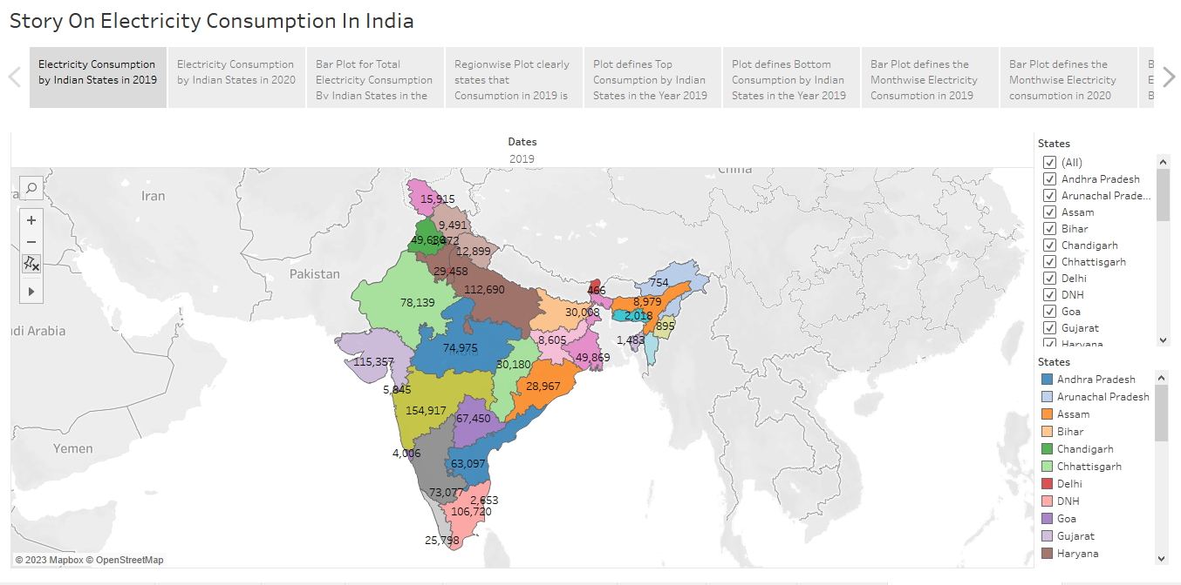

4.ADVANTAGES &DISADVANTAGES:

**These ideas helps**

* **to reduce electricity bills,**
* **extend the life of your devices,**
* **increases our energy security etc.,**

**But the disadvantage is the cost for construction is high.**

5.APPLICATIONS:

People use electricity mostly for cooling and heating, they do not have any net carbon dioxide emissions.

The industrial sector uses electricity for operating in industrial motors and machinery, lights, computers and office equipment for facility heating, cooling and ventilation.

6.CONCLUSION:

From our analysis we conclude that Maharashtra is the highest electricity consumer.

And also we came to know that electricity consumption during lockdown (March 2020-june2020) was less compared to 2019.

And Total Electricity consumption in western regions is the highest.

.